Best Deals
Great offer Pay just Rs.699 for an chance to win Samsung Galaxy Note 2 worth Rs.36900.
You either win or we refund 100% of your money to shop at svaiza

What's the Contest
• Svaiza.com will conduct a lucky draw every month.
• 15 lucky winners will be chosen through a Lucky Draw conducted by svaiza and informed by email.
• Participants of the contest will get 100% cash back as a credit points. 1 credit point = Rs.1
• User can buy any products on svaiza.com using credit points.
• User can view his credit points in my-account section and same can be used while shopping in the cart page
• Get Instant full Money Back as shopping credits to buy products at unbelievable prices
BUY NOW
• Enter Your Details To Get this product
• Name :
• Mobile :
• Email :
• Address :
• City :
• State :
• Pincode :
•
SUBMIT

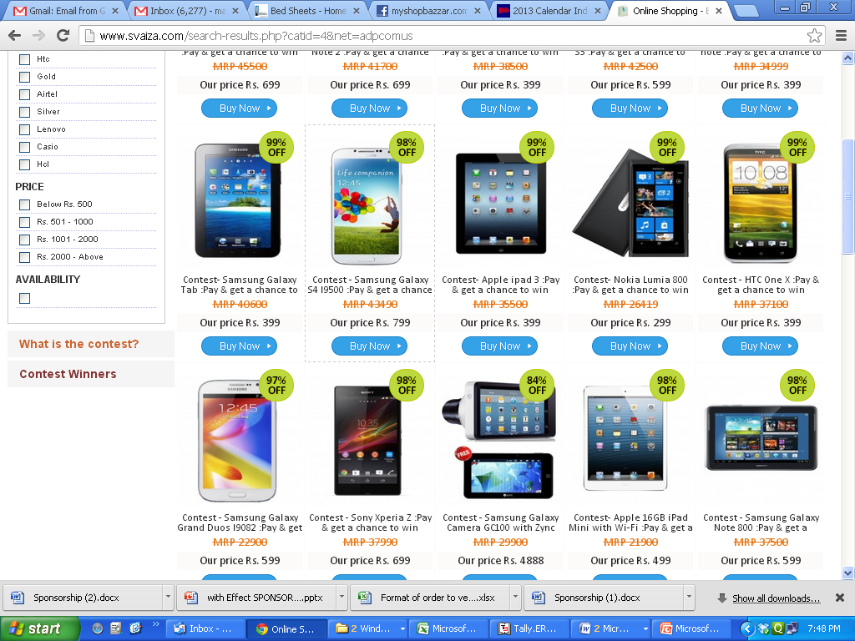
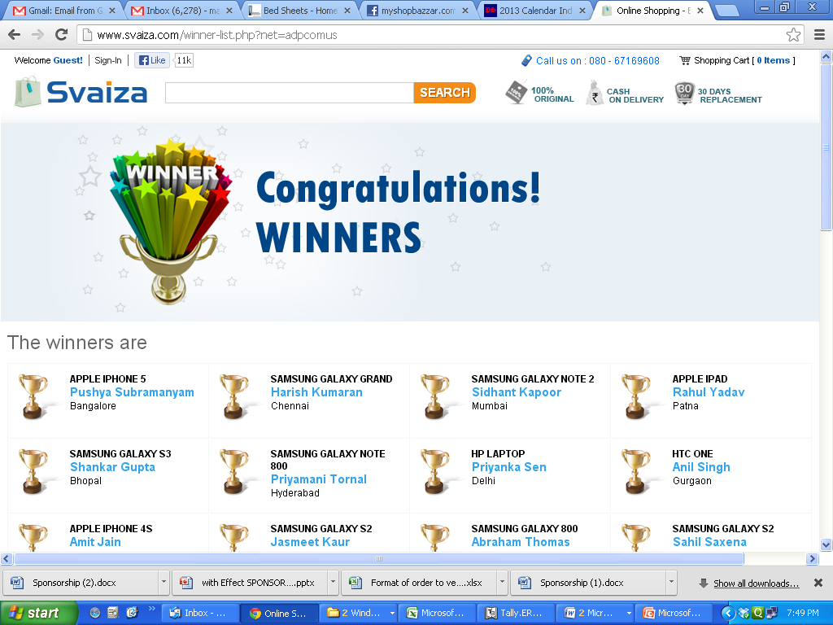

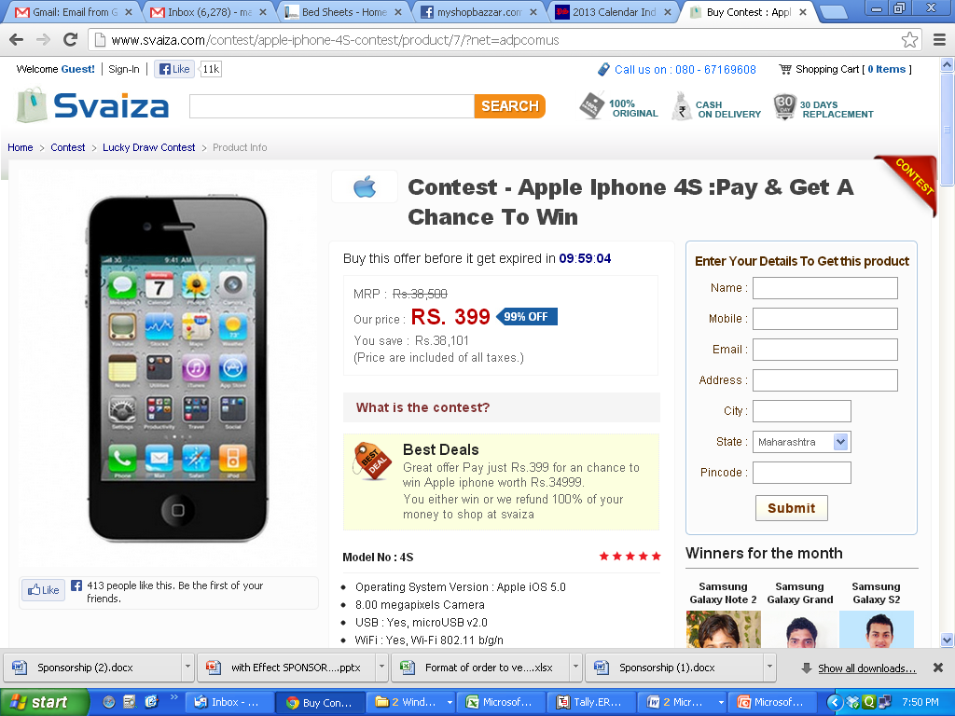

Terms and Conditions

Acceptance of Contest Terms and Conditions
1. Svaiza.com will conduct a lucky draw every month electronically through a randomized program conducted by svaiza.
2. We will choose 15 lucky winners through a lucky draw conducted by svaiza.com.
3. Participants of the contest will get 100% cash back as a credit points. 1 credit point = Rs.1
4. Winner will get the confirmation through call and email.
5. User can buy any products on svaiza.com using credit points.
6. User can view his credit points in my-account section and same can be used while shopping in the cart page.
7. Svaiza shall under no circumstance exchange the reward for cash or kind
8. Get Instant full Money Back as shopping credits to buy products at unbelievable prices.
9. Cash Back will be given only in terms of credits points only.
10.If the credit point is not reflecting in your svaiza account,please do inform us within 8 days of purchase else warranty will be expired and we will be not able to add your credit points.
11.Contest gets renewed every month.
12.Svaiza reserves the right to modify,amend,cancel,update or withdraw the promotion at any time without any notice.
13.In case of redemption,user will be automatically ineligible for contest.
14.If you win the contest,credit points will be removed from your svaiza account
15.Winner of a month will be announced on 1st week of a registered next month
16.Contest coupon is valid for 100 days
17.There is no product delivery involved in this as it is an online contest.
18.Contest coupon cannot be cancelled or refunded.Cash back is done only in terms of credit points.
19.You may win the lucky draw in different product category also.

Terms and Conditions

Acceptance of Terms and Conditions
svaiza.com ("svaiza" or "Site" or "We" or "Our") is an Internet based content and e-commerce website owned and operated by Seajin Technology. By using the svaiza.com, You are deemed to have accepted the terms and conditions listed below.
By using the services of the website, you are agreeing to all the T&Cs listed below. svaiza reserves the right to update or modify these terms and conditions at any time without prior notice. The conditions are applicable on your visit to the website svaiza.com or use of any service or purchase of any product from svaiza, hence you are advised to read this Agreement carefully..
Membership Eligibility
Use of the Site is available only to persons who can form legally binding contracts under applicable law. Persons who are "incompetent to contract" within the meaning of the Indian Contract Act, 1872 including un-discharged insolvents etc. are not eligible to use the Site. If you are a minor i.e. under the age of 18 years but at least 13 years of age you may use this Site only under the supervision of a parent or legal guardian who agrees to be bound by these Terms of Use. If your age is below that of 18 years your parents or legal guardians can transact on behalf of you if they are registered users. You are prohibited from purchasing any material which is for adult consumption and the sale or purchase of which to/by minors are strictly prohibited.
svaiza.com reserves the right to terminate your membership and refuse to provide you with access to the Site if svaiza.com discovers that you are under the age of 18 years. The Site is not available to persons whose membership has been suspended or terminated by svaiza.com for any reason whatsoever. If you are registering as a business entity, you represent that you have the authority to bind the entity to this User Agreement. Unless otherwise specified, the materials on this website are directed solely at those who access this website from India. svaiza.com makes no representation that any products or services referred to in the materials on this website are appropriate for use, or available outside India. Those who choose to access this Site from outside India are responsible for compliance with local laws if and to the extent local laws are applicable. svaiza.com will deliver the products only within India and will not be liable for any claims relating to any products ordered from outside India.
Pricing Information
Except where noted otherwise, the Selling Price/svaiza price/MRP/MOP/List Price displayed for products on our website represents the full retail price listed on the product itself, suggested /offered by the manufacturer or supplier or one of our merchants/affiliates, or estimated in accordance with standard industry practice; or the estimated retail value for a comparably featured item offered elsewhere. The Selling Price/svaiza price/MRP/MOP/List Price is a comparative price estimate and may or may not represent the prevailing price in every area on any particular day. For certain items that are offered as a set/pack/combo/arrangement, the Selling Price/List Price/svaiza price may represent "open-stock" prices, which mean the aggregate of the manufacturer's estimated or suggested retail price for each of the items included in the set/pack/combo/arrangement. The final price that will be applicable to a user for purchase and payment will be as per the price that is displayed in the shopping cart of the customer which can be inclusive or exclusive of any other charges in terms of the usage of the website.
Account and Registration Obligations
In consideration of your use of the Site, you represent that you are of legal age to form a binding contract and are not a person barred from receiving services or goods under the laws as applicable in India. You also agree to provide true, accurate, current and complete information about yourself as prompted by the Site's registration form. If you provide any information that is untrue, inaccurate, not current or incomplete (or becomes untrue, inaccurate, not current or incomplete), or svaiza has reasonable grounds to suspect that such information is untrue, inaccurate, not current or incomplete, svaiza has the right to suspend or terminate your account and refuse any and all current or future use of the Site. If you use the Site, you are responsible for maintaining the confidentiality of your account and password, and for restricting access to your computer. You agree to accept responsibility for all activities that occur under your account or password. Because of this, we strongly recommend that you exit from your account at the end of each session. You agree to notify svaiza immediately of any unauthorized use of your account or any other breach of security. svaiza reserves the right to refuse service, terminate accounts, or remove or edit content in its sole discretion.
Risk of Loss
All items purchased from svaiza.com are made pursuant to a shipment contract. This means that the risk of loss and title for such items pass to you upon the delivery to the carrier by the vendor/merchant/affiliate/manufacturer.
Credit Card Details
You understand and confirm that the credit card details provided by you for availing of services on svaiza.com will be correct and accurate and you shall not use the credit card which is not lawfully owned by you, i.e. in a credit card transaction, you must use your own credit card. You further agree and undertake to provide the correct and valid credit card details to svaiza.com. Further the said information will not be utilized and shared by svaiza.com with any of the third parties unless required for fraud verifications or by law, regulation or court order. svaiza.com will not be liable for any credit card fraud. The liability for use of a card fraudulently will be on you and the onus to 'prove otherwise' shall be exclusively on you.
Fraudulent /Declined Transactions
svaiza.com reserves the right to recover the cost of goods, collection charges and lawyers fees from persons using the Site fraudulently. svaiza.com reserves the right to initiate legal proceedings against such persons for fraudulent use of the Site and any other unlawful acts or acts or omissions in breach of these terms and conditions.
Electronic Communications
When you visit the Site or send emails to us, you are communicating with us electronically. You consent to receive communications from us electronically. We will communicate with you by email or by posting notices on the Site. You agree that all agreements, notices, disclosures and other communications that we provide to you electronically satisfy any legal requirement that such communications be in writing.
Cancellation by svaiza.com
Please note that there may be certain orders that we are unable to accept and must cancel. We reserve the right, at our sole discretion, to refuse or cancel any order for any reason. Some situations that may result in your order being cancelled include limitations on quantities available for purchase, inaccuracies or errors in product or pricing information, or problems identified by our credit and fraud avoidance department. We may also require additional verifications or information before accepting any order. We will contact you if all or any portion of your order is cancelled or if additional information is required to accept your order. If your order is cancelled after your credit card has been charged, the said amount will be reversed back in your Card Account.
Cancellations by the Customer
In case we receive a cancellation notice and the order has not been shipped by us, we shall cancel the order and refund the entire amount. The orders that have already been shipped out by us will not be cancelled and you will have to check our return policy on those orders. The customer agrees not to dispute the decision made by svaiza.com and accept svaiza.com’s decision regarding the cancellation.
You Agree and Confirm
1. That you are accessing the services available on this Site and transacting at your sole risk and are using your best and prudent judgment before entering into any transaction through this Site
2. That in the event that a non-delivery occurs on account of a mistake by you (i.e. wrong name or address or any other wrong information) any extra cost incurred by svaiza.com for redelivery shall be claimed from you.
3. That before placing an order you will check the product description carefully. By placing an order for a product you agree to be bound by the conditions of sale included in the item's description.
You may not use the Site for any of the following purposes:
1. Disseminating any unlawful, harassing, libelous, abusive, threatening, harmful, vulgar, obscene, or otherwise objectionable material.
2. Transmitting material that encourages conduct that constitutes a criminal offence results in civil liability or otherwise breaches any relevant laws, regulations or code of practice.
3. Gaining unauthorized access to other computer systems.
4. Interfering with any other person's use or enjoyment of the svaiza Site.
5. Breaching any applicable laws;
6. Interfering or disrupting networks or web sites connected to the Site.
7. Making, transmitting or storing electronic copies of materials protected by copyright without the permission of the owner.

Trademark, Copyright and Restriction
This site is controlled and operated by Seajin technology. All material on this site, including images, illustrations, audio clips, and video clips, are protected by copyrights, trademarks, and other intellectual property rights that are owned and controlled by us or by other parties that have licensed their material to us. Material on svaiza.com website owned, operated, licensed or controlled by us is solely for your personal, non-commercial use. You must not copy, reproduce, republish, upload, post, transmit or distribute such material in any way, including by e-mail or other electronic means and whether directly or indirectly and you must not assist any other person to do so. Without the prior written consent of the owner, modification of the materials, use of the materials on any other web site or networked computer environment or use of the materials for any purpose other than personal, non-commercial use is a violation of the copyrights, trademarks and other proprietary rights, and is prohibited. Any use for which you receive any remuneration, whether in money or otherwise, is a commercial use for the purposes of this clause.
Governing Law and Jurisdiction
This User Agreement shall be construed in accordance with the applicable laws of India. The Courts at Bangalore shall have exclusive jurisdiction in any proceedings arising out of this agreement.
Any dispute or difference either in interpretation or otherwise, of any terms of this User Agreement between the parties hereto, the same shall be referred to an independent arbitrator who will be appointed by seajin Technology. and his decision shall be final and binding on the parties hereto. The above arbitration shall be in accordance with the Arbitration and Conciliation Act, 1996 as amended from time to time. The arbitration shall be held in Bangalore. The High Court of judicature at Bangalore alone shall have the jurisdiction and the Laws of India shall apply.
Objectionable Material
You understand that by using this Site or any services provided on the Site, you may encounter Content that may be deemed by some to be offensive, indecent, or objectionable, which Content may or may not be identified as such. You agree to use the Site and any service at your sole risk and that to the fullest extent permitted under applicable law, svaiza.com and its affiliates shall have no liability to you for Content that may be deemed offensive, indecent, or objectionable to you.
Indemnity
You shall indemnify and hold harmless svaiza.com, its subsidiaries, affiliates, third-parties and their respective officers, directors, agents, and employees, from any claim or demand, or actions including reasonable attorneys' fees, made by any third party or penalty imposed due to or arising out of your breach of the User Agreement and Terms and Conditions or your violation of any law, rules or regulations or the rights of a third party.
Data Protection
svaiza.com may send information and offers of products and services to you from time to time. For further details relating to our policy relating to such offer please refer to our privacy policy.
Termination:
svaiza.com may suspend or terminate your use of the Website or any Service if it believes, in its sole and absolute discretion that you have breached a term of these Terms.If you or svaiza.com terminates your use of the Website or any Service, svaiza.com may delete any content or other materials relating to your use of the Service and svaiza.com will have no liability to you or any third party for doing so.You shall be liable to pay for any Service or product that you have already ordered till the time of Termination by either party whatsoever. Further, you shall be entitled to your royalty payments as per the User License Agreement that has or is legally deemed accrued to you.
Disclaimer Of Warranties/Limitation Of Liability:
svaiza.com has endeavoured to ensure that all the information on the Website is correct, but svaiza.com neither warrants nor makes any representations regarding the quality, accuracy or completeness of any data, information, product or Service. In no event shall svaiza.com be liable for any direct, indirect, punitive, incidental, special, consequential damages or any other damages resulting from: (1) the use or the inability to use the Services; (2) unauthorized access to or alteration of the user's transmissions or data; (3) any other matter relating to the services; including, without limitation, damages for loss of use, data or profits, arising out of or in any way connected with the use or performance of the Website or Service. Neither shall svaiza.com be responsible for the delay or inability to use the Website or related services, the provision of or failure to provide Services, or for any information, software, products, services and related graphics obtained through the Website, or otherwise arising out of the use of the website, whether based on contract, tort, negligence, strict liability or otherwise. Further, svaiza.com shall not be held responsible for non-availability of the Website during periodic maintenance operations or any unplanned suspension of access to the website that may occur due to technical reasons or for any reason beyond svaiza's control. The user understands and agrees that any material and/or data downloaded or otherwise obtained through the Website is done entirely at their own discretion and risk and they will be solely responsible for any damage to their computer systems or loss of data that results from the download of such material and/or data.
Contest
1. svaiza.com will conduct a lucky draw every month.
2. We will choose 15 lucky winners through a lucky draw conducted by svaiza.com.
3. Participants of the contest will get 100% cash back as a credit points. 1 credit point = Rs.1
4. Winner will get the confirmation through email.
5. User can buy any products on svaiza.com using credit points.
6. User can view his credit points in my-account section and same can be used while shopping in the cart page.
7. Get Instant full Money Back as shopping credits to buy products at unbelievable prices.
8. Cash Back will be given only in terms of credits points only.
9. If the credit point is not reflecting in your svaiza account,please do inform us within 8 days of purchase else warranty will be expired and we will be not able to add your credit points.
Site Security
Users are prohibited from violating or attempting to violate the security of this site, including, without limitation, (a) accessing data not intended for such user or logging onto a server or an account that the user is not authorized to access; (b) attempting to probe, scan, or test the vulnerability of a system or network or to breach security or authentication measures without proper authorization; (c) attempting to interfere with service to any user, host, or network, including, without limitation, by means of submitting a virus to the site, overloading, "flooding," "spamming," "mailbombing" or "crashing"; (d) sending unsolicited e-mail, including promotions and/or advertising of products or services; or (e) forging any TCP/IP packet header or any part of the header information in any email or newsgroup posting. Violations of system or network security may result in civil or criminal liability. svaiza will investigate occurrences that may involve such violations and may involve, and cooperate with, law enforcement authorities in prosecuting users who are involved in such violations. You agree not to use any device, software or routine to interfere or attempt to interfere with the proper working of this site or any activity being conducted on this site..
Entire Agreement
These Terms of Service constitute the entire agreement between the parties with respect to the subject matter hereof and supersedes and replaces all prior or contemporaneous understandings or agreements, written or oral, regarding such subject matter. The clauses as above shall survive the termination or expiry of this agreement. This electronic record is generated by a computer system and does not require any physical or digital signatures.

Contact Details:
svaiza.com
Seajin Technology
# 2/1, 1st Floor, JC Industrial Estate,
Yelachenahalli, Kanakapura Road,
Bangalore - 560062
E-mail: info@svaiza.com

